Chapter 16, Problem 52.

If the switch in Fig. 16.75 has been closed for a long time before t = 0 but is opened at t = 0, determine i_{x} and v_{R} for t > 0.

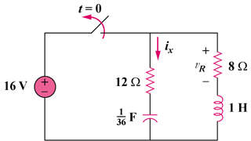

Figure 16.75
For Prob. 16.52.

